**ANSIBLE DOCUMENT**

**Organize the project structure**

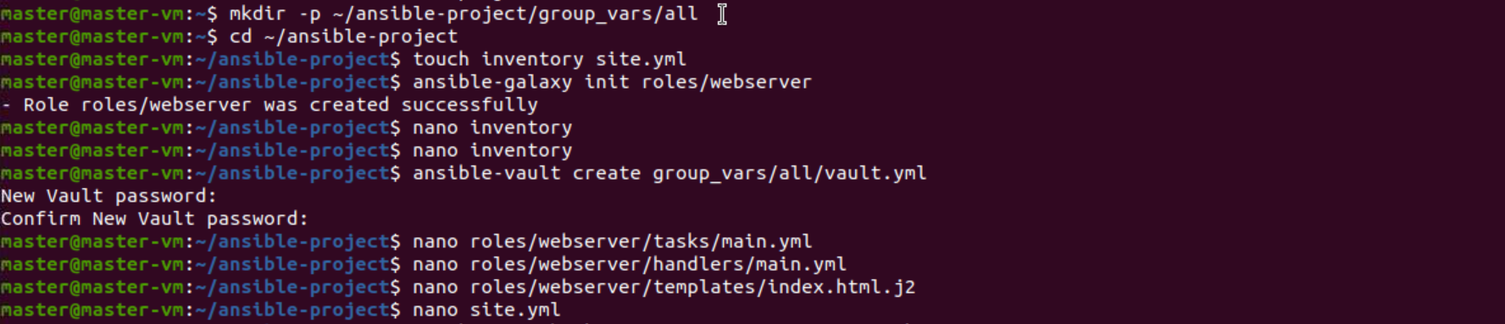

**Inventory file**

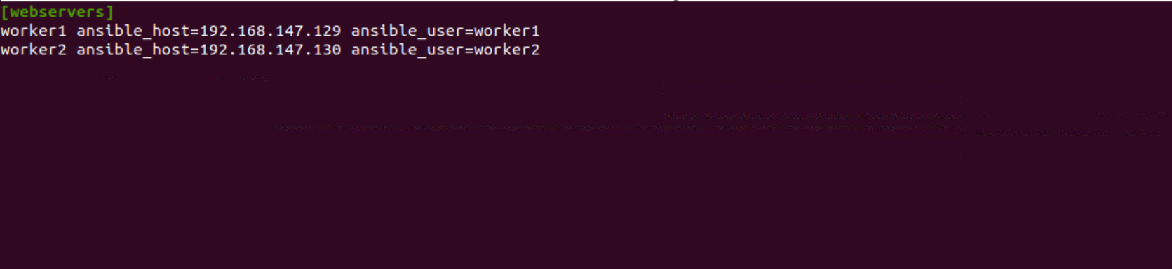

**Roles/webserver/tasks/main.yml**

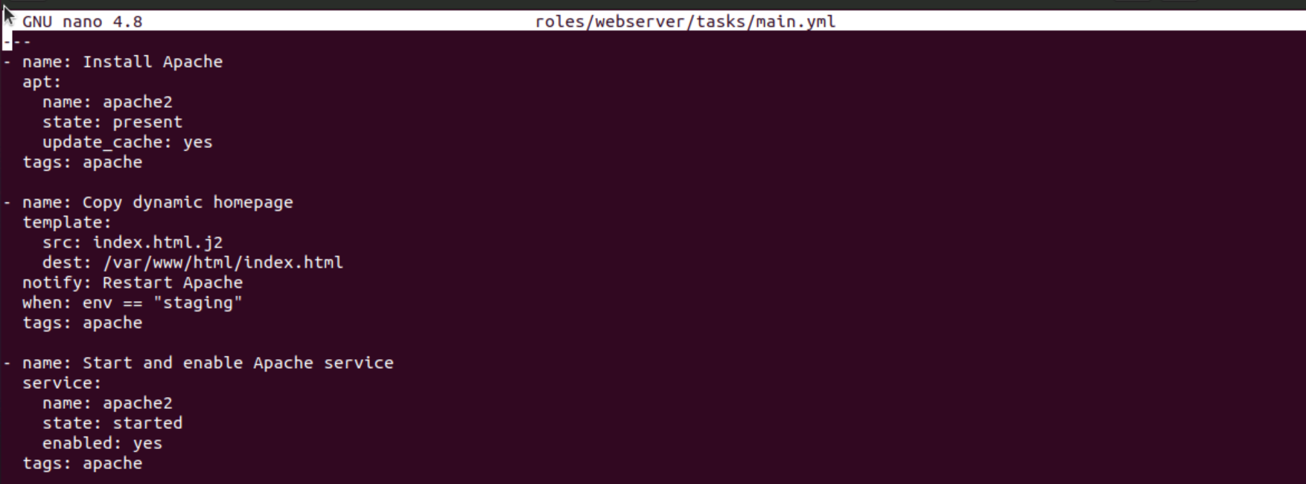

**Handlers file:**

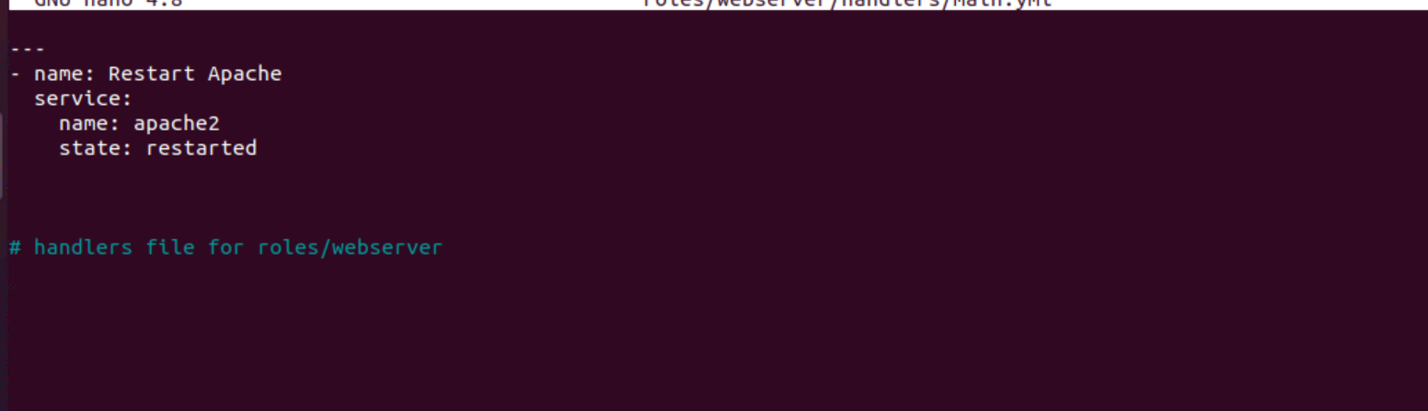

**Site.yml**

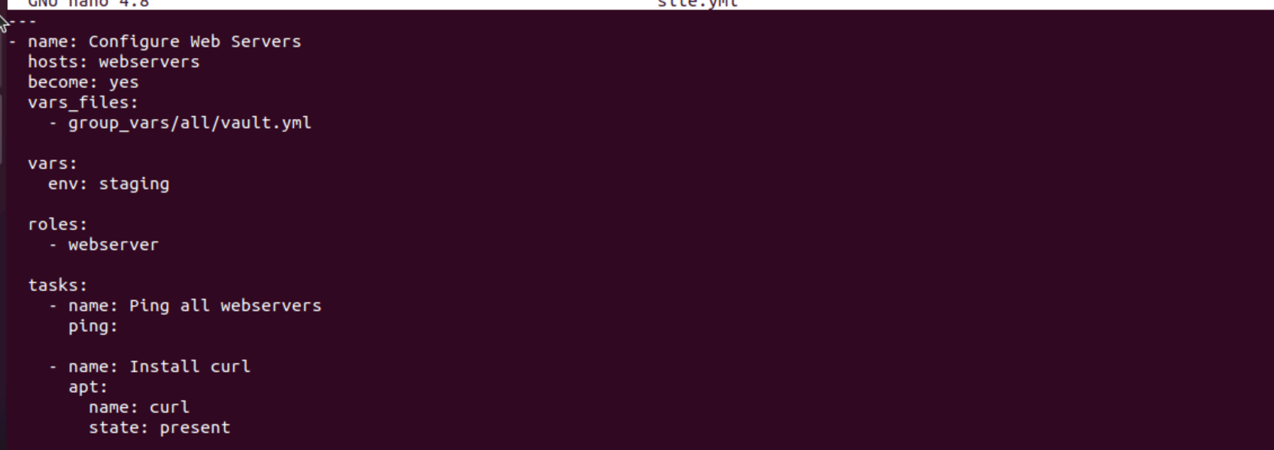

**Html file:**

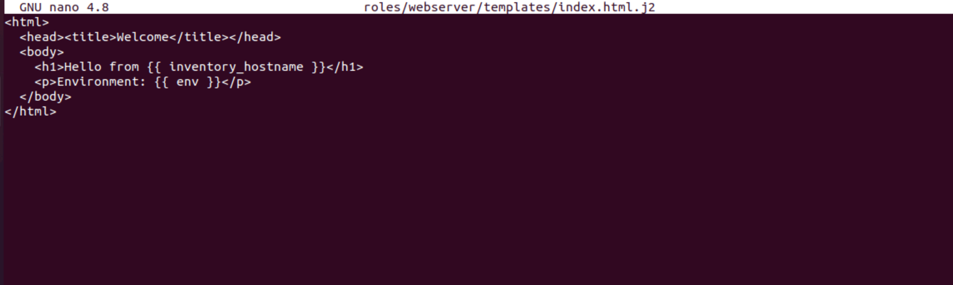

**Output :-**

